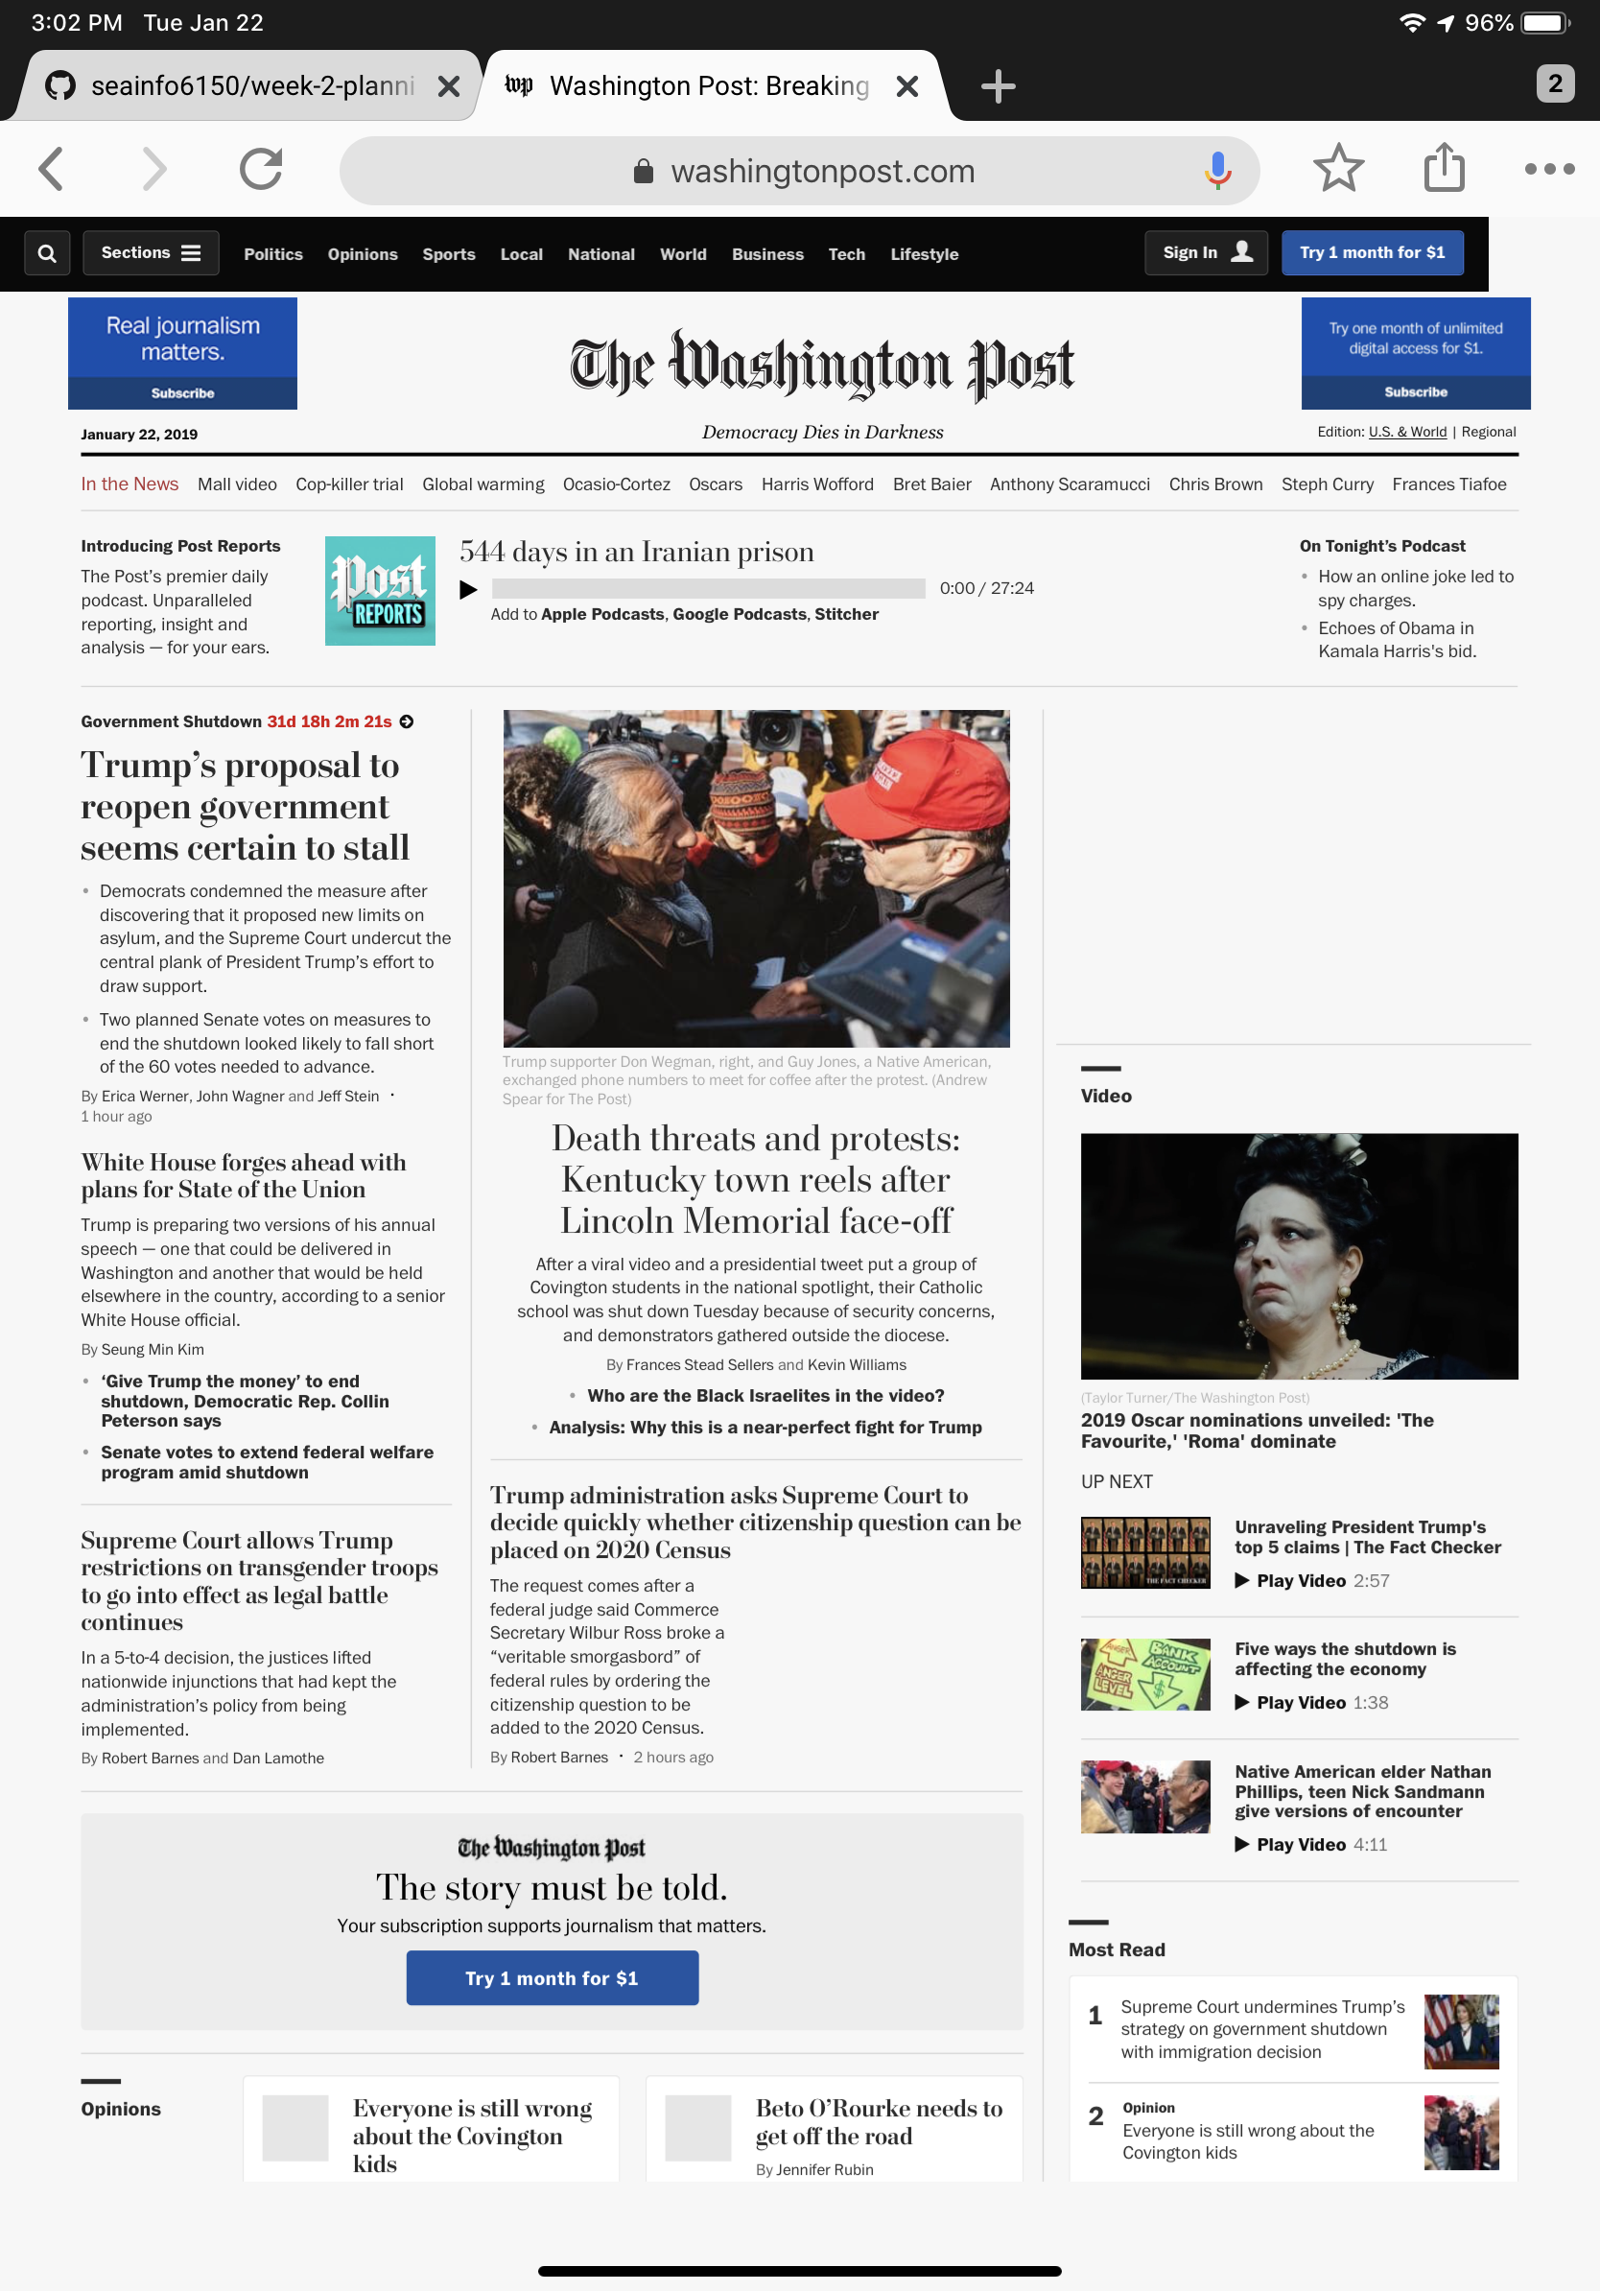

The Washington post, just like the New York Times, it is one of the largest news agency in the United States. And their website is now one of their main platform for posting their articles.

The screenshot showed the current Washington Post front page. The reading experiences is responsive and loaded really fast. Navigation between stories is pretty easier and with only one action, including a click, swipe or a tap, can simply shows the user more contents.

The website still kept the newspaper style design, so the user will have the newspaper reading feeling while they are reading it. The contrast of the website is high. The photos and videos are showing some colors and everything else but the subscribe button is purely black and white with high hierarchy. All blue buttons are for users to subscribe to their news service, so it will set up a cognitive idea for the user that what the blue action button is for.

The animation between pages is also showing some movement, for users to changes sections, is just like turning pages in a newspaper.

The grid of the website is also pretty strong, it shows clear sections for users to understand what part covers this whole story. And the whole website design is consistent. Overall the Washington Post is a well designed newspaper. However personally I still prefer the New York Times’ website because of its font. (Fonts matter!)

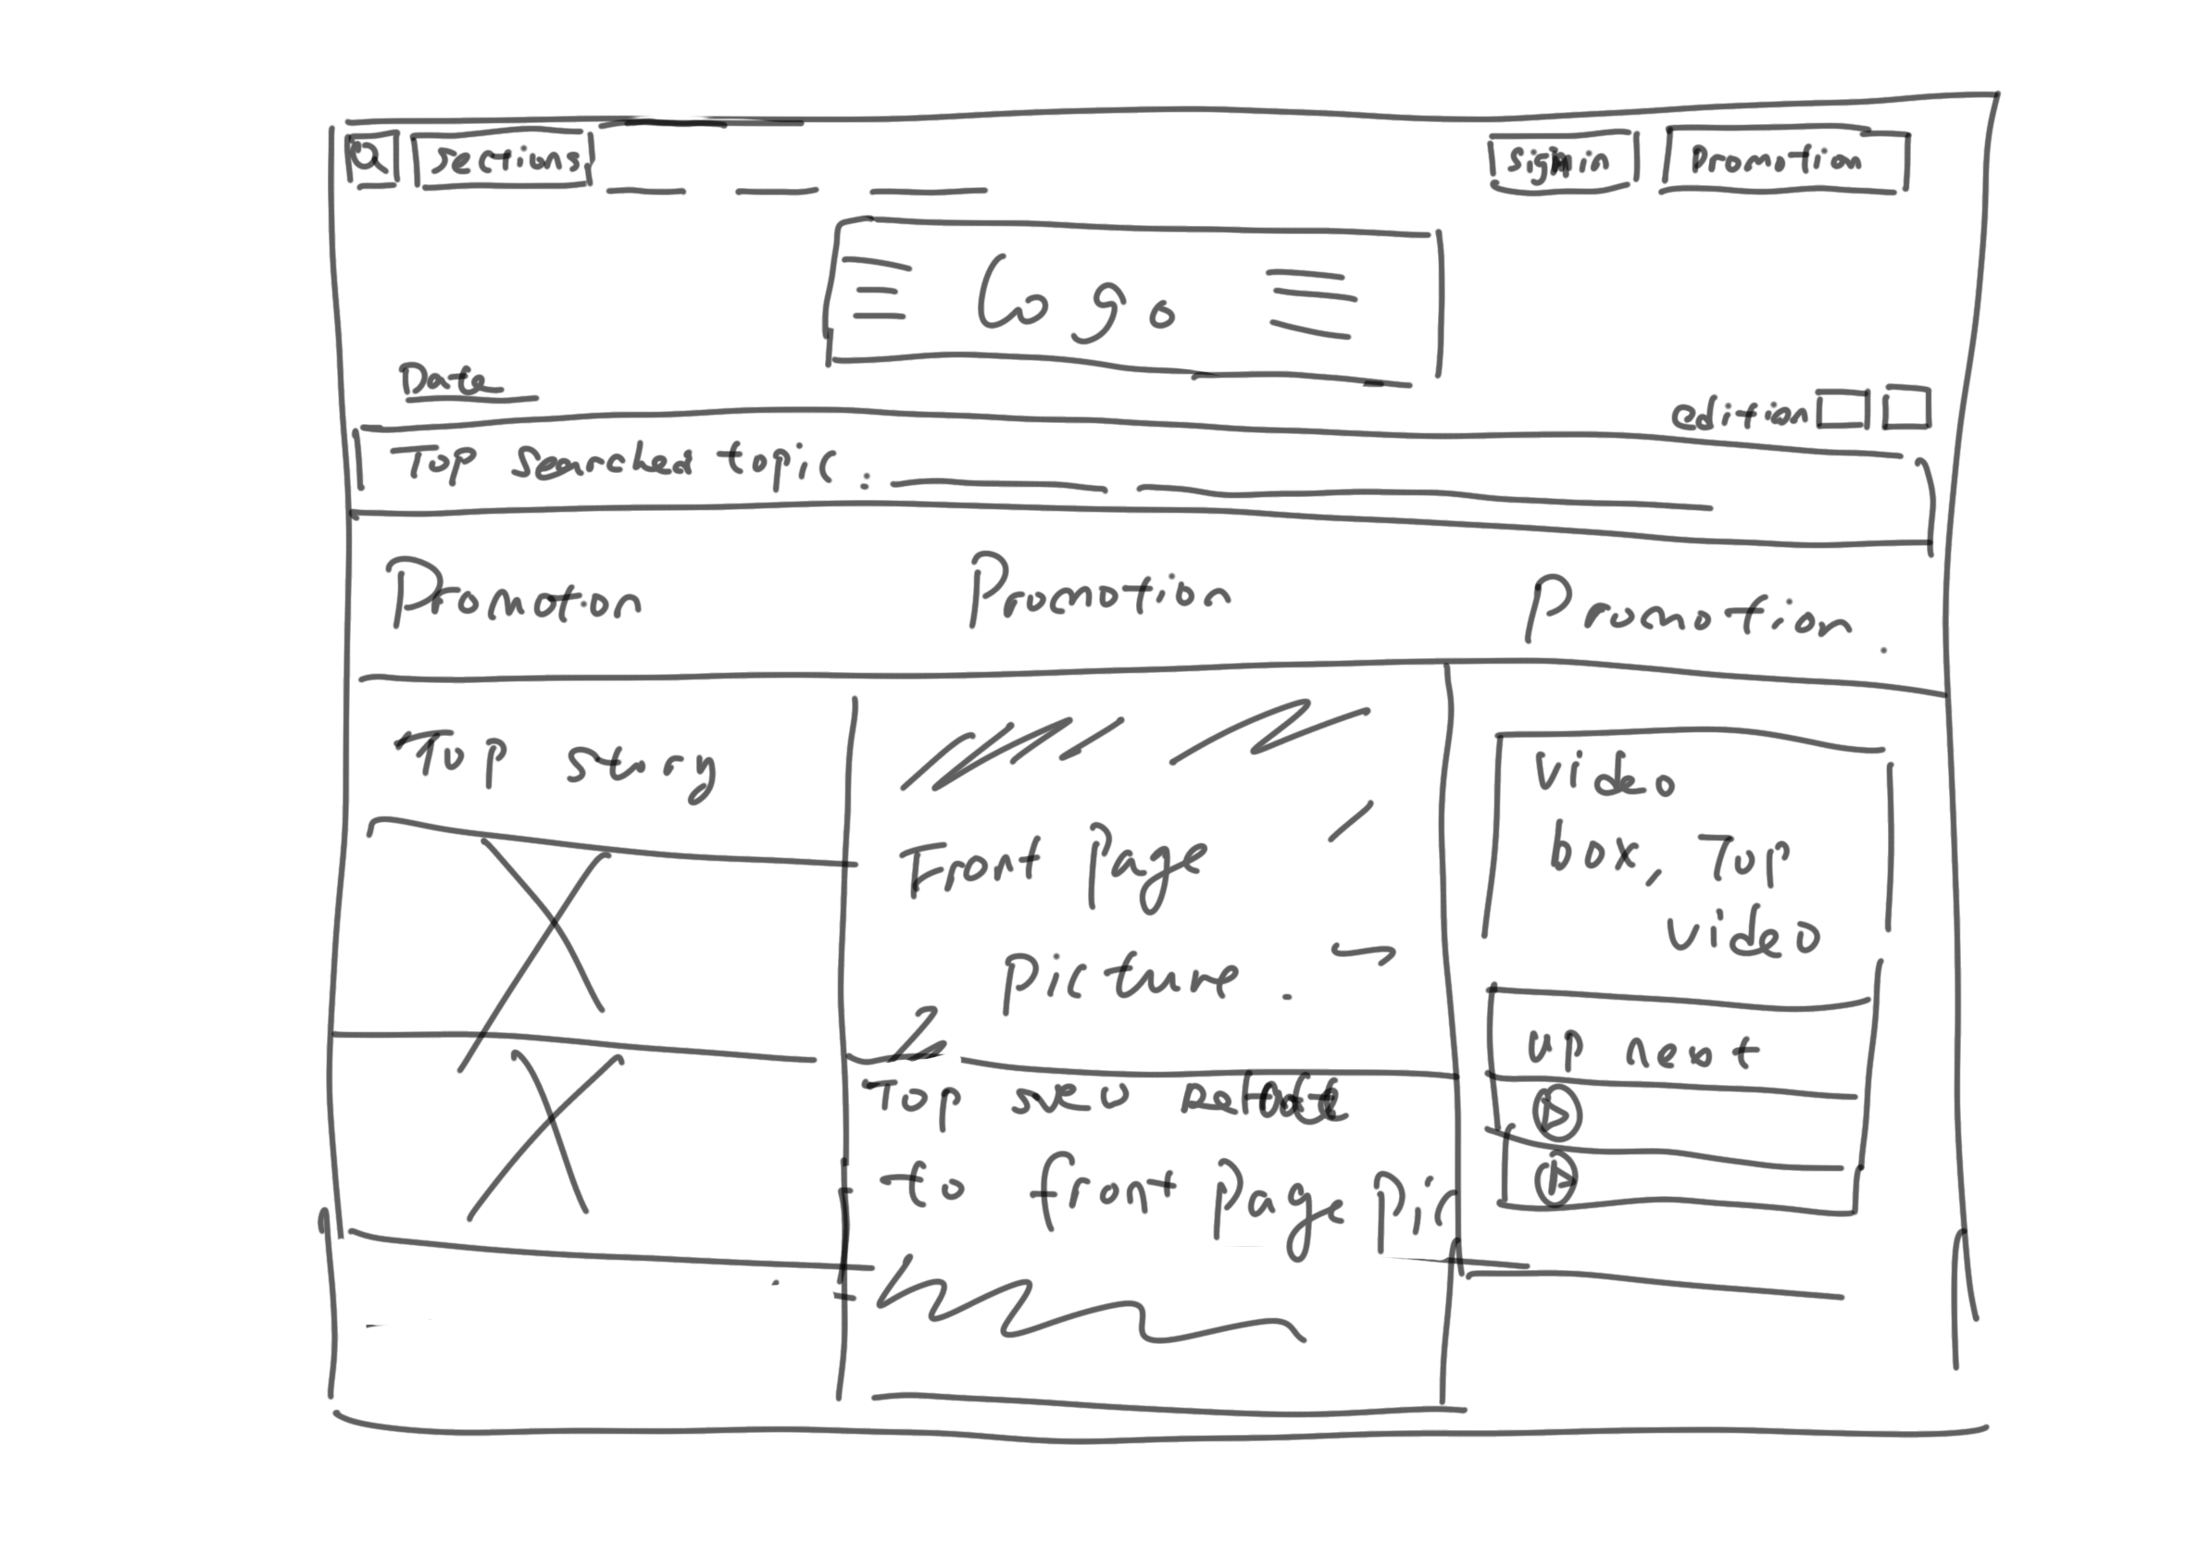

This is my hand draw version of the Washington Post’s wireframe.

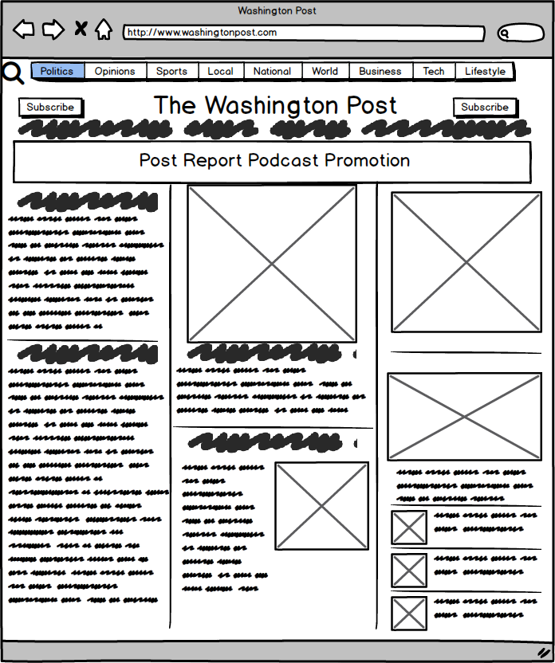

This is my design using balsamiq